**Final Project Report**

In the final project, I created a solar system, and added several other features which included the concepts of Texture Mapping and Lighting. In this report, I will be describing the following:

1.**Proposal**

In the final project, I will be implementing Solar System along with some other features of Computer Graphics.

I will be using **Lighting** and **Texture Mapping** in implementing the solar system. Creating a solar system with all the planets revolving around the sun and also the moon revolving around the Earth (within their orbits) is going to be challenging for me. I am also planning to create the rings around some of the planets. Apart from planets, there is going to be some other celestial bodies too.

I am planning to include one additional menu title, ‘Lighting’ which will have some sub-menus to turn on and off the light shining on the planets revolving around the sun. So, this is going to involve the **lighting concepts** that we studied in the class.

I am going to use different kind of textures on different planets, the moon, and the sun, which is going to involve reading in the texture images from the .bmp files as we did in our **texture mapping** project.

Apart from this, I am planning to show some colored air balls flying in the space and falling on the planets. So for this, I am going to include one more menu title, ‘Colored Balls’ to enable or disable the colored balls flying and falling on the planets.

While using this, users will be able to do the rotation and scaling of the scene as they were able to do in the other projects. There will be a camera too to scale (zoom in/zoom out) the scene in X, Y and Z directions with the help of keyboard keys.

The features I am going to use in my final project, are basically texture mapping and lighting. To implement them, I need to use all the concepts of lighting and texture mapping that I learned in the class. Creating the solar system involving the revolution of the planets around the sun, within their orbits in the space, will lead me to learn something new while applying the concepts of lighting and texture mapping together to a completely different project. Hope this results in a good final project.

2. **Accomplishments**

I made the solar system using C++ language in OpenGl and since I added some features to it like the colored balls, lighting effect and the texture mapping, I learned these concepts in more depth as there was a great use of texture mapping and lighting in this project.

Once the user executes the code, he will see the space full of stars and planets revolving around the sun.

I also create several other switches to handle in my scene, such as, “Lights”, to turn the lighting effect on and off. Once the user switches on the Light, he would be able to see the light shinning on the planets revolving around the Sun.

There is an another switch called “ColoredBalls” to turn on and off the different colored balls. Once the user turns on the switch “ColoredBalls”, he would be able to see different colored balls flying and falling on the planets revolving around the Sun.

Apart from doing the scaling and rotating with the help of mouse, the user can also use the keyboard keys, “ABCDEG” to scale and rotate the scene.

3. **Differences**

The major difference between what I have done in the project and what I proposed are the stars in the sky that I created. I did mention that I will be adding some other celestial bodies too in my project but by saying that I meant some meteorites falling on the planets. However, while doing the project, I realized creating stars in the sky would be a better idea than the meteorites (as I am already making some colored balls fall on the planets) and it would make the scene look more natural and realistic.

4. **Insights**

If I talk about the insights, one is the colored balls, falling from top to bottom randomly. However, it was a little hard to implement, it looks pretty cool. Coding the colored balls required a lot of random numbers. I initialized the starting points of the colored balls, the falling speed of each ball, the directions and the speed of each ball to random.

Another important insight is the sky box which was easy to implement. The sky box is basically a box with the same star sky texture mapping to inner sides of six faces. Since the texture itself is the stars shining on a dark black background, the edges and corners of the box are really hard to see. This makes the box look like space, and the depths of the surface is also hard to tell. However, the scene looks pretty natural and realistic.

5. **Things I Learned**

There were a lot of things in the project which made me look and study for the concepts of lighting and texture mapping in depth.

Since there are a lot of textures in this project that we need to map (by reading it in through .bmp files) on the celestial bodies, so I got to practice that a lot as I used textures on the Sun, and the other nine planets. I applied star sky texture on the sky box.

The other thing is the application of lighting which I got to practice in this project as I implemented the light shining on the planets revolving around the Sun. Also, I implemented the light switch to turn the light “on” and “off”.

Lastly, I also got to exercise my geometry calculation skills as to implement the planets, revolving around the Sun, and the Airballs falling on the planets, required intense calculations in order to simulate them. I was also required to set both the texture coordinates and the normals for the surface which included a lot of calculation work.

6. **Screenshots**

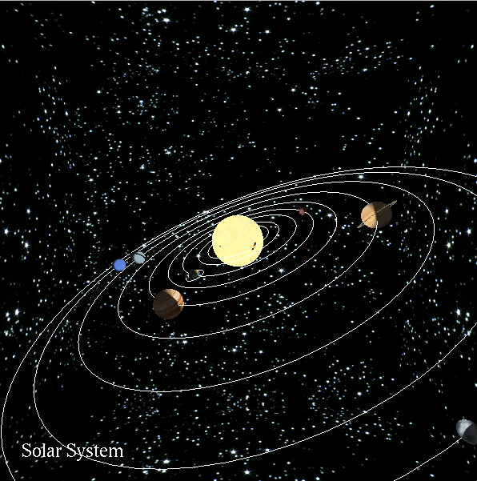

**Figure1. Solar System**

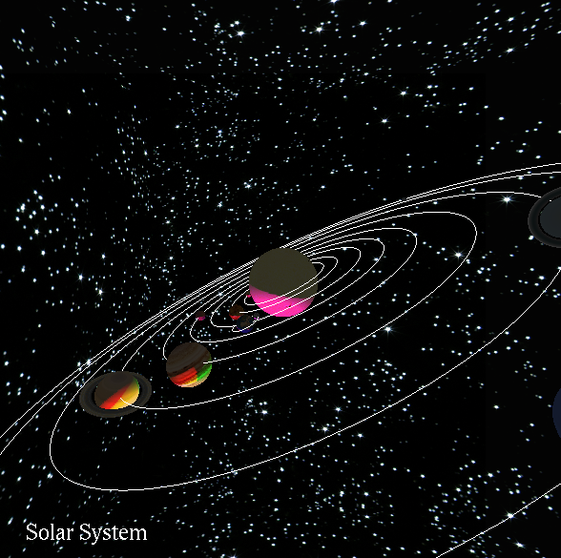

**Figure2. Lighting Effect**

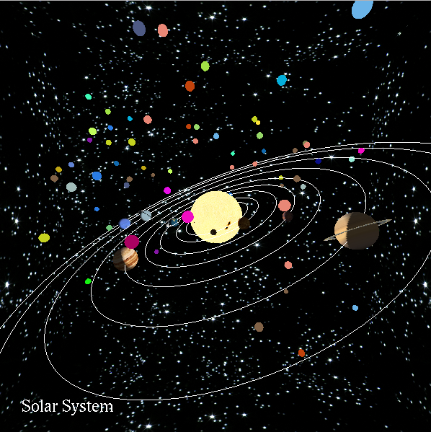

**Figure3. Colored Balls**

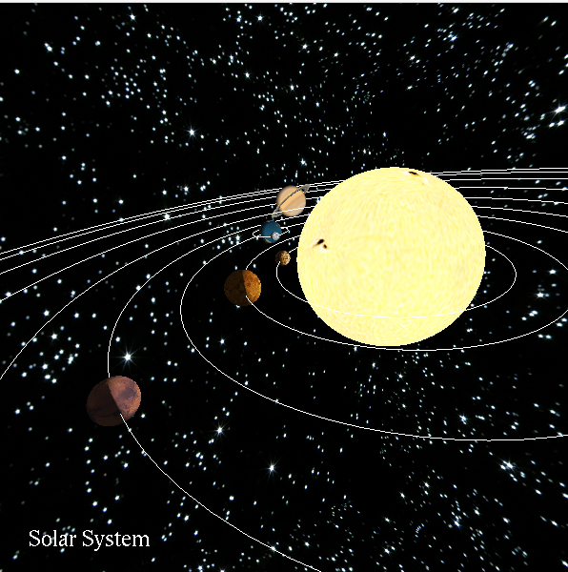

**Figure4. Zoomed in using Keyboard Keys**

7. **Youtube Video Link:**

[**https://youtu.be/NqFoshz_4bQ**](https://youtu.be/NqFoshz_4bQ)